**Demo for the project**

**To be able to access the Ai model get API key and Paste it in .env file**

This is the interface

First we will select the image

After clicking the Select Image button select the image from which the logo u have to remove

After selecting the image, the model will automatically detect the logo and a mask will be created into another image

This is the image for 1 test with opaque background

The result is

After this we will click on the process button to continue



After clicking the process button the request will be sent to all the Ai models which ever Ai response is first I will be displayed in automatic mode you can even select the any particular model if needed

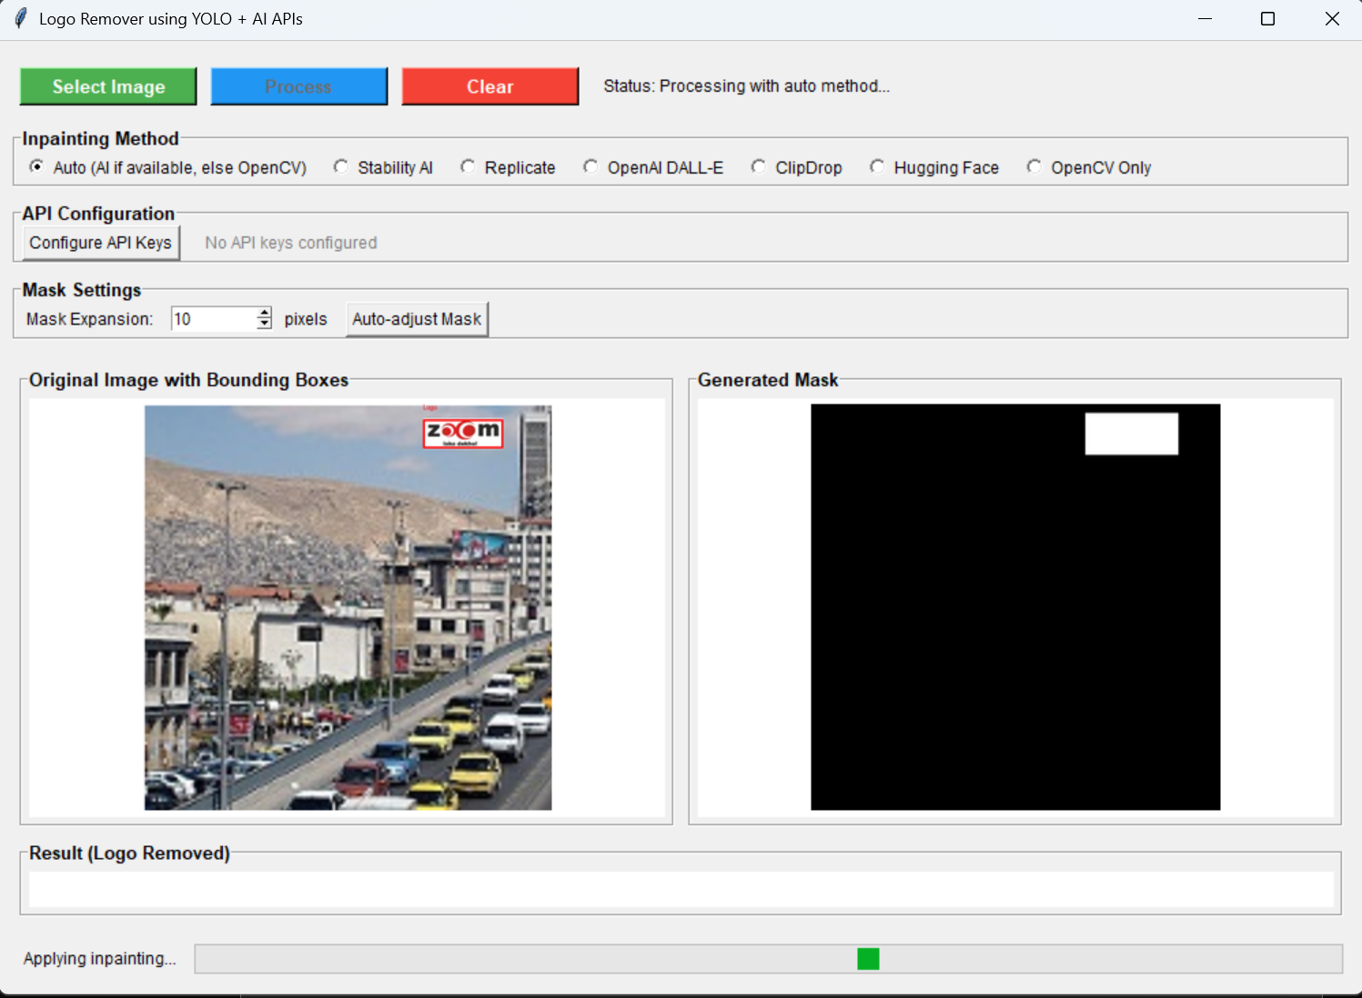

A message will be displayed in Status and the progress bar will show the progress

Then the result will be displayed

If your Device is offline, it will use open cv model which is the basic Inpainting model.

The image will be saved in Mask and Output folder By default you can even save it to clipboard for convenience or in any file.

Test Case: 2

Image

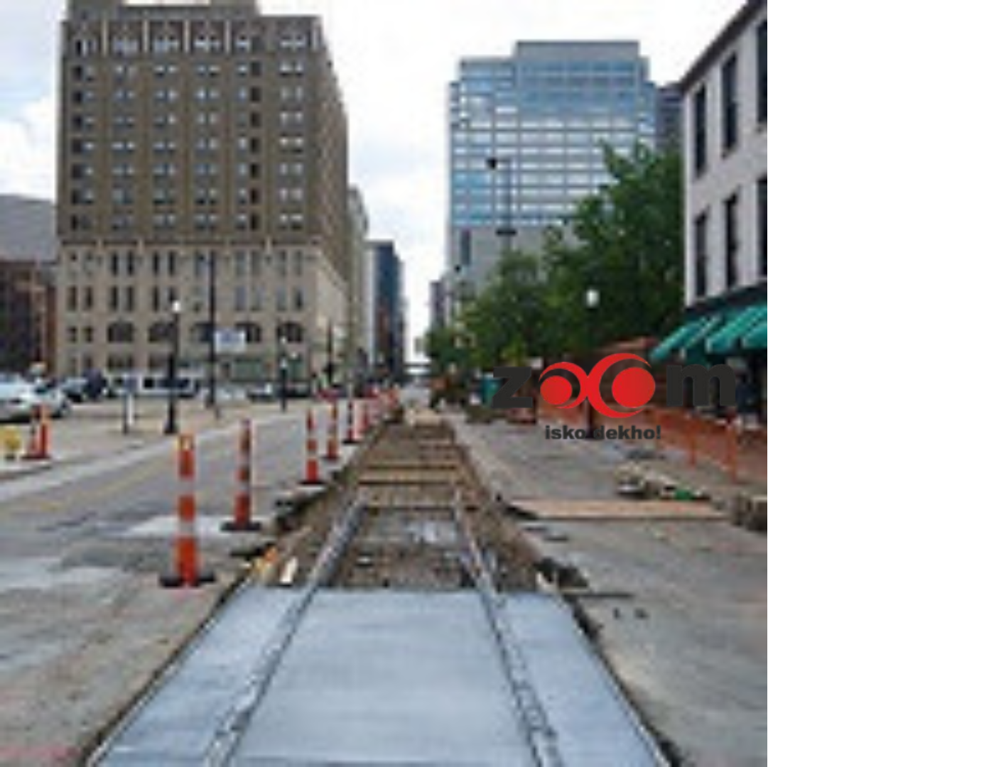

The zoom logo in this is very much camouflaged in the background but the Yolo Model will detect it

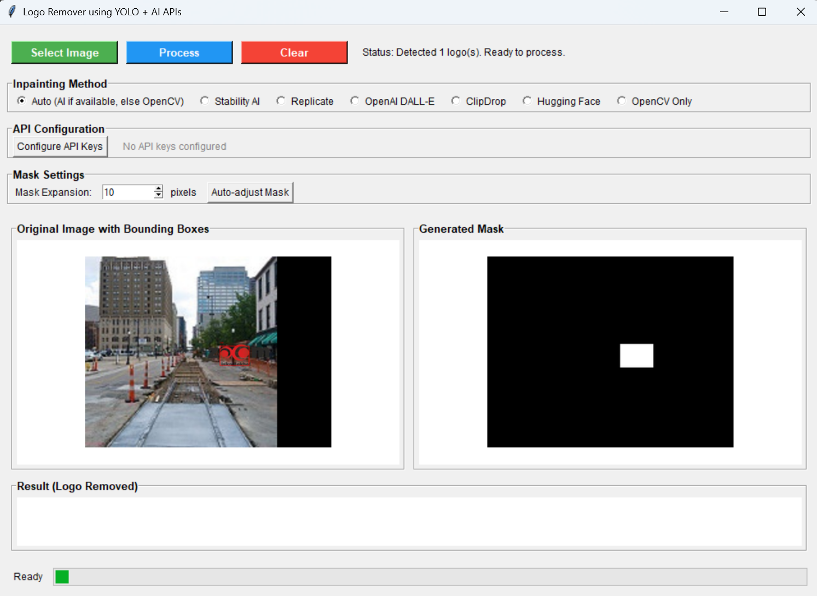

The result:

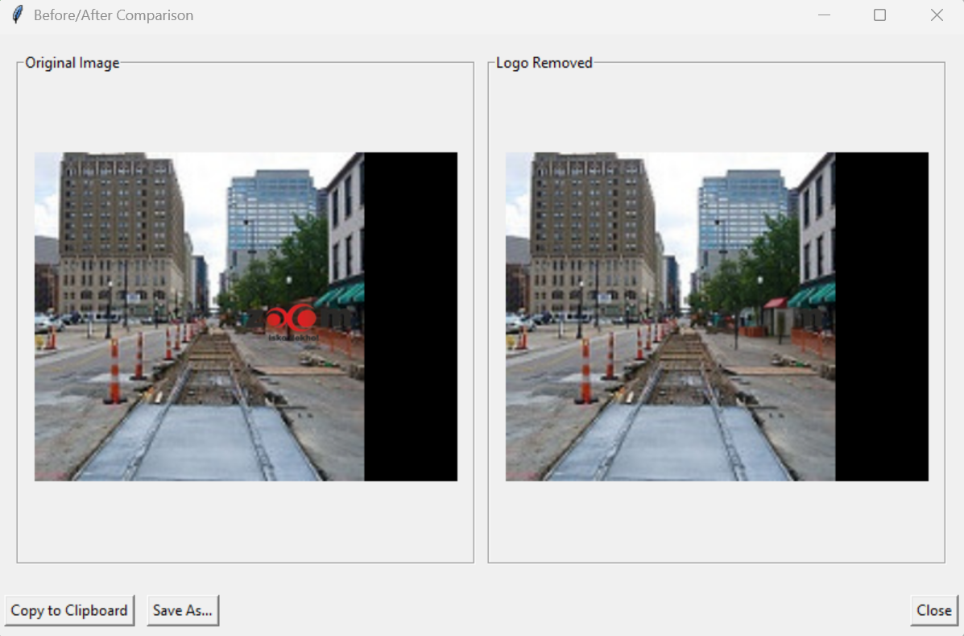

Test 3:

The process:

The Result:

